**Penetration Testing or Pen Test**

**Penetration testing** is like a simulated cyberattack. It's done to find weaknesses in a computer system, network, or website that a hacker could use to break in.

**Here's how it works:**

1. **Gathering Information:** First, people who do the testing learn as much as they can about the system they're testing.
2. **Finding Weak Spots:** They look for ways to get into the system, like open doors or weak passwords.
3. **Trying to Break In:** They try to use these weak spots to access the system.
4. **Reporting Results:** After they're done, they tell the people who own the system about the weaknesses they found.

**Why do it?**

* **Find Problems:** It helps to find security problems before a real hacker can exploit them.
* **Test Security:** It shows how well the system's security measures are working.
* **Check Policies:** It can help test if the company's security rules are being followed.
* **Train Employees:** It can help train employees to be aware of security threats.

**In short, penetration testing is like a dress rehearsal for a cyberattack, and it helps make systems safer.**

**Penetration Testing Life Cycle- Phases**

**A Visual Breakdown of Penetration Testing Lifecycle**

**1. Scoping:**

* **Defining the Target:** This involves identifying the specific systems, networks, or applications to be tested.
* **Setting Goals:** Determining the objectives of the test, such as identifying vulnerabilities, assessing security measures, or simulating specific attack scenarios.

**2. Reconnaissance:**

* **Gathering Information:** Collecting publicly available data about the target, including network architecture, software versions, and security policies.
* **Identifying Entry Points:** Identifying potential vulnerabilities or weak points that could be exploited.

**3. Vulnerability Detection:**

* **Scanning:** Using automated tools to scan the target for known vulnerabilities, such as open ports, weak passwords, or outdated software.
* **Identifying Risks:** Assessing the potential impact of identified vulnerabilities.

**4. Information Analysis and Planning:**

* **Prioritizing Vulnerabilities:** Determining which vulnerabilities pose the greatest risk to the system.
* **Developing Attack Strategies:** Creating plans to exploit identified vulnerabilities.

**5. Penetration Testing:**

* **Executing Attacks:** Simulating real-world attacks to test the effectiveness of security measures.
* **Monitoring and Analyzing:** Observing the system's response to attacks and collecting evidence.

**6. Privilege Escalation:**

* **Gaining More Access:** Attempting to elevate privileges within the system to gain more control.
* **Identifying Additional Vulnerabilities:** Discovering new vulnerabilities that may be accessible with elevated privileges.

**7. Result Analysis:**

* **Evaluating Findings:** Analyzing the results of the penetration test to identify successful attacks and vulnerabilities.
* **Assessing Impact:** Determining the potential impact of discovered vulnerabilities.

**8. Reporting:**

* **Documenting Findings:** Creating a detailed report summarizing the findings, vulnerabilities, and recommendations.
* **Providing Recommendations:** Suggesting steps to mitigate identified risks and improve security.

**9. Cleanup:**

* **Reversing Changes:** Undoing any changes made during the test to restore the system to its original state.
* **Ensuring Confidentiality:** Protecting any sensitive information obtained during the test.

**Note:** The specific steps and tools used in a penetration test may vary depending on the scope, objectives, and complexity of the target system.

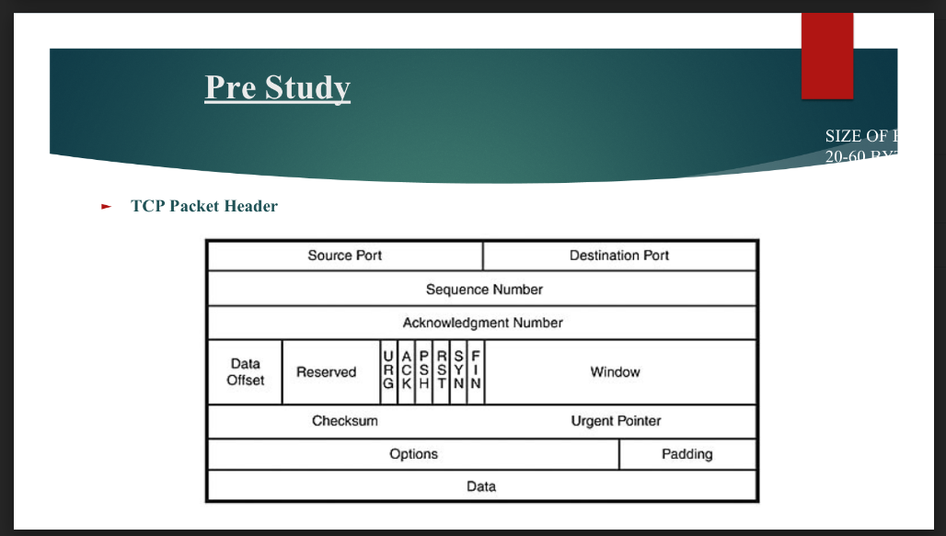

**TCP Packet Header**

The image you provided shows the **TCP packet header**. This header is a crucial part of a Transmission Control Protocol (TCP) segment, which is a unit of data transmitted over a network.

Let's break down the different components of the TCP packet header:

**Source Port:** This field specifies the port number on the sending computer from which the data originated.

**Destination Port:** This field indicates the port number on the receiving computer where the data is intended to go.

**Sequence Number:** This field is used to keep track of the order of data packets in a TCP connection. It helps ensure that packets are received in the correct order.

**Acknowledgment Number:** This field is used to acknowledge the receipt of data packets. It contains the sequence number of the next packet expected to be received.

**Data Offset:** This field indicates the location of the actual data within the TCP segment.

**Reserved:** This field is reserved for future use and is currently set to 0.

**URG:** This flag indicates whether the data in the segment is urgent.

**ACK:** This flag indicates whether the segment is an acknowledgment of a previously received segment.

**PSH:** This flag indicates that the data in the segment should be pushed to the receiving application as soon as possible.

**RST:** This flag indicates that the connection should be reset.

**SYN:** This flag indicates that this is a synchronization segment, used to establish a new TCP connection.

**FIN:** This flag indicates that this is a finish segment, used to terminate a TCP connection.

**Window:** This field specifies the size of the receiving window, which indicates how much data the receiver can accept at once.

**Checksum:** This field contains a checksum value used to verify the integrity of the data in the segment.

**Urgent Pointer:** This field is used in conjunction with the URG flag to indicate the location of urgent data within the segment.

**Options:** This field is optional and can contain various options, such as timestamps, window scaling, and selective acknowledgments.

**Padding:** This field is used to pad the segment to a multiple of 4 bytes, which is required for some network interfaces.

The TCP packet header plays a vital role in ensuring reliable and efficient data transmission over a network. It provides the necessary information for establishing connections, sequencing data, and acknowledging the receipt of data.

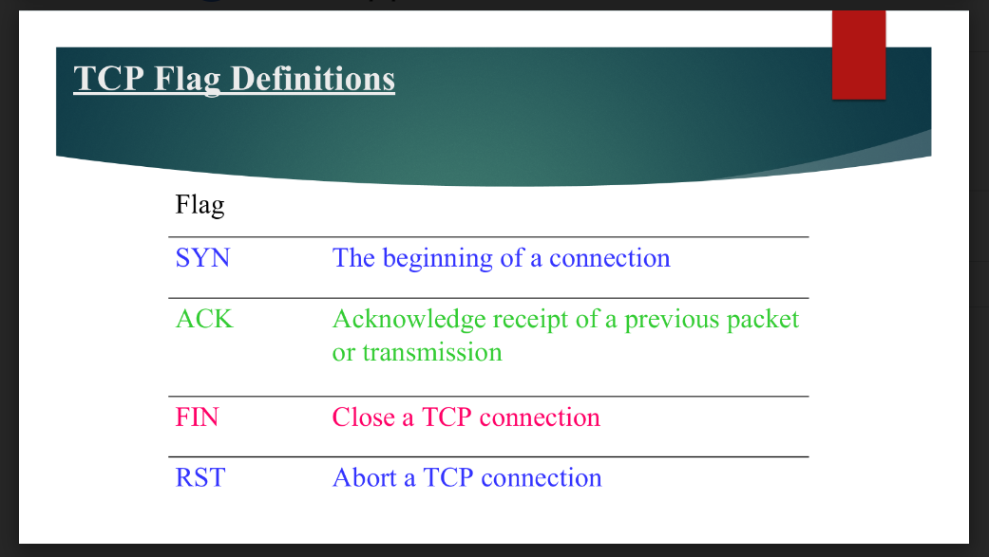

The image you provided defines the different flags used in TCP (Transmission Control Protocol) communication. These flags are used to control the flow of data and establish connections between devices on a network.

Here's a breakdown of each flag:

* **SYN:** This flag is used to initiate a new TCP connection. It signifies the start of a communication session.
* **ACK:** This flag is used to acknowledge the receipt of a previous data packet. It ensures that data is transmitted reliably and without errors.
* **FIN:** This flag is used to terminate a TCP connection. It signals that one side of the connection is closing down.
* **RST:** This flag is used to reset a TCP connection. It can be used to abort a connection if there is an error or if one side wants to terminate it abruptly.

These flags work together to establish, maintain, and terminate TCP connections, ensuring reliable and efficient data transmission between devices on a network.

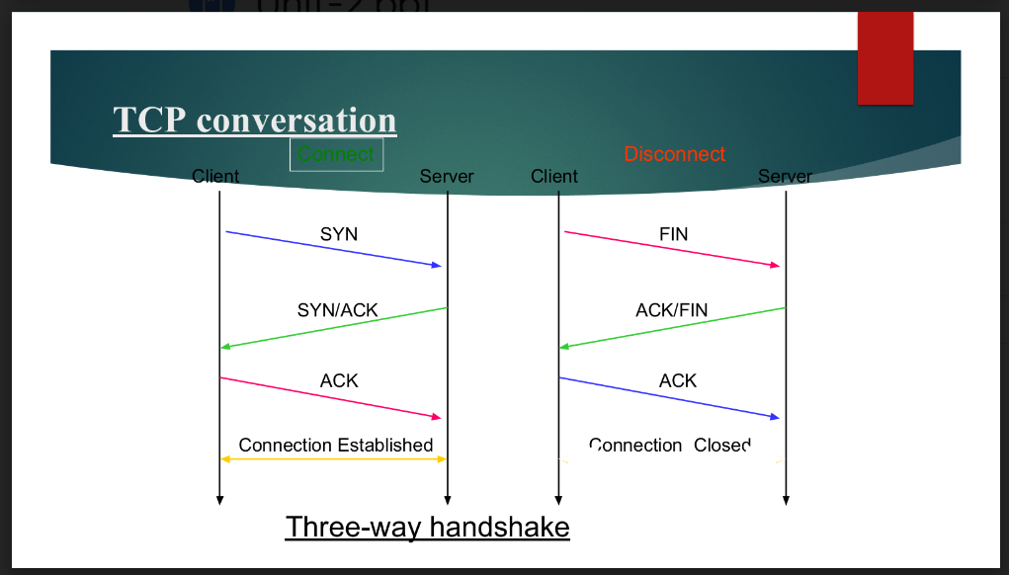

The image shows a TCP (Transmission Control Protocol) conversation between a client and a server. TCP is a protocol used to establish reliable connections between devices on a network.

**Here's a breakdown of what's happening in the image:**

1. **Client sends a SYN packet:** The client initiates a connection by sending a SYN packet to the server. This packet says, "I want to start a connection."
2. **Server responds with SYN/ACK:** The server acknowledges the client's request by sending a SYN/ACK packet. This packet says, "I received your request and I'm ready to start a connection. Send me an ACK packet to confirm."
3. **Client sends an ACK packet:** The client confirms the connection by sending an ACK packet to the server. This packet says, "I received your SYN/ACK and I'm ready to start the connection."
4. **Connection established:** At this point, the connection is established and data can be transmitted between the client and the server.
5. **Client sends a FIN packet:** The client initiates the closing of the connection by sending a FIN packet to the server. This packet says, "I'm done with this connection."
6. **Server responds with ACK/FIN:** The server acknowledges the client's request to close the connection and also sends a FIN packet to indicate that it is also closing the connection.
7. **Client sends an ACK packet:** The client acknowledges the server's FIN packet, indicating that the connection is closed from its side.
8. **Connection closed:** At this point, the connection is officially closed.

This process is known as the **three-way handshake** and is a fundamental part of establishing TCP connections. It ensures that both the client and the server are ready to communicate and that the connection is reliable.

**What is Nmap? and give any 5 commands in details .**

Nmap (Network Mapper) is a free and open-source network scanning tool used to discover hosts on a network and gather information about them. It can be used for a variety of purposes, such as network administration, security audits, and penetration testing.

Here are 5 common Nmap commands with detailed explanations:

**1. Simple Scan:**

* **Command:** nmap <target>
* **Purpose:** This command performs a basic scan of the specified target, identifying active hosts on the network and their open ports.
* **Example:** nmap 192.168.1.1-254 scans all hosts on the 192.168.1.0/24 network.

**2. Host Discovery:**

* **Command:** nmap -sn <target>
* **Purpose:** This command is used to discover hosts on a network without scanning their ports. It can be useful for identifying active systems without alerting them.
* **Example:** nmap -sn 192.168.1.1-254 discovers active hosts on the 192.168.1.0/24 network without scanning their ports.

**3. Port Scan:**

* **Command:** nmap -p <port_range> <target>
* **Purpose:** This command scans a specific range of ports on a target host to identify open ports.
* **Example:** nmap -p 22,80,443 google.com scans ports 22, 80, and 443 on google.com.

**4. Service Detection:**

* **Command:** nmap -sV <target>
* **Purpose:** This command identifies the services running on open ports of a target host.
* **Example:** nmap -sV 192.168.1.100 identifies the services running on the host 192.168.1.100.

**5. OS Detection:**

* **Command:** nmap -O <target>
* **Purpose:** This command attempts to identify the operating system of a target host based on its responses to network traffic.
* **Example:** nmap -O 192.168.1.100 tries to determine the operating system of the host 192.168.1.100.

These are just a few examples of Nmap commands. Nmap offers many more options and features for customizing scans and gathering detailed information about networks and hosts.

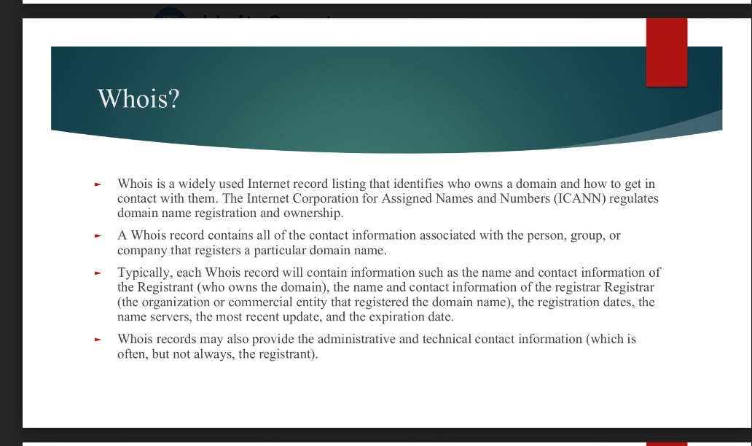

Whois is a public database that provides information about registered domain names. It allows you to look up the owner, contact information, registration date, and other details associated with a specific domain name.

**Here's a breakdown of the information you can find in a Whois record:**

* **Registrant:** The individual, organization, or company that owns the domain name.
* **Registrar:** The company that registered the domain name.
* **Registration date:** The date when the domain name was first registered.
* **Expiration date:** The date when the domain name registration will expire.
* **Name servers:** The DNS servers that are responsible for resolving the domain name to an IP address.
* **Updated date:** The date when the Whois record was last updated.
* **Administrative contact:** The person or organization responsible for administrative tasks related to the domain name.
* **Technical contact:** The person or organization responsible for technical support and maintenance of the domain name.

**How to use Whois:**

To find the Whois information for a domain name, you can use a variety of online tools and websites. Many domain registrars and internet service providers offer Whois lookup services. You can also use command-line tools like whois on Linux and macOS systems.

**Example:**

To find the Whois information for the domain name example.com, you would enter the following command in your terminal:

whois example.com

This would display the Whois record for example.com, containing information about the registrant, registrar, registration date, and other details.

**Important note:**

While Whois records can be a valuable tool for finding information about domain names, it's important to note that privacy concerns have led to some changes in how Whois information is displayed. In some cases, the contact information may be redacted or obscured to protect the privacy of the registrant.